Database AT2 REPORT

Name: Ali Albayrak

Student ID: P304320

Development:

1. List (and describe) the information that your database is required to hold:

* Bookings –

Invoice number, event date , number of guests

* Food-

Food id, description of food, cost and size

* Clients-

Client id, first name, family name, address, phone number, comment

* Locations-

Suburb name, postcode

1. List the functionality of the database you will create (how will a user interact with your database?).

Database will store all the information about clients, foods, locations and bookings. Users will interact with database via php menus.

1. Design an entity-relationship (ER) diagram to model the relationships between the entities and attributes the database will hold.

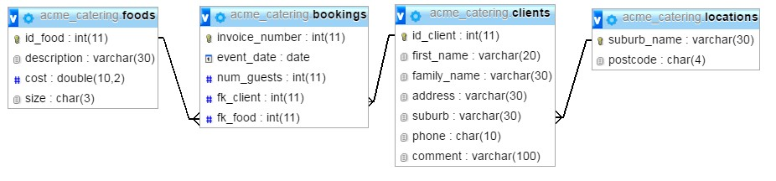

1. Explain the primary and foreign keys to link the entities.

Food table:

* Primary key: id_food

Locations Table:

* Primary key: suburb_name

Clients table:

* Primary key: id_client
* Foreign Key: suburb_name

Bookings table:

* Primary key : invoice_number
* Foreign keys: fk_client and fk_food

1. Develop a Data Dictionary (ref Appendix A)

|  |  |  |  |  |
| --- | --- | --- | --- | --- |
| ***Data Object Name*** | ***Name*** | ***Attribute Size*** | ***Data Type*** | ***Description*** |
| **Database Name** | catering | n/a | n/a | The primary name of the database that holds the table information |
| **Table Names** | Clients | n/a | n/a | The primary table that holds the people information |
|  | Locations | n/a | n/a | The secondary table that holds the location details |
|  | Foods | n/a | n/a | The third table that holds foods information |
|  | bookings | n/a | n/a | The fourth table that holds booking details |
| **Field Names**  (attributes) | Id_client | Auto | Autonumber | The primary key for the Table |
|  | First_name | 20 | char | A Persons first name |
|  | Family_name | 30 | char | A Persons family name |
|  | Address | 30 | char | A Persons Address |
|  | suburb | 30 | Char | A Persons Suburb |
|  | Phone | 10 | Char | A Persons Phone number |
|  | Comment | 100 | Char | A comment from the person to the catering service |
|  | Suburb_name | 30 | char | Foreign Key from the table locations on clients table |
|  | Suburb_name | 30 | Char | The primary key for the locations table |
|  | Postcode | 4 | Char | A locations postcode |
|  | Id_food | 11 | Int | The primary key for the table |
|  | Description | 30 | Char | A food description |
|  | Cost | 10,2 | Double | A food cost |
|  | Size | 3 | Char | A meal size |
|  | Invoice_number | 11 | Int | The primary key for the table |
|  | Event_date | Auto | date | A date of the event |
|  | Num_guests | 11 | Int | The number of guests |
|  | Fk_client | 11 | Int | Foreign key from the table clients |
|  | Fk_food | 11 | int | Foreign key from the food |

# TESTING

1. Describe how you are going to test your application (i.e. list all test scenarios)

We can test the application by testing user interface(menus and submenus).

1. Provide results for each test from the previous question (screen shots)

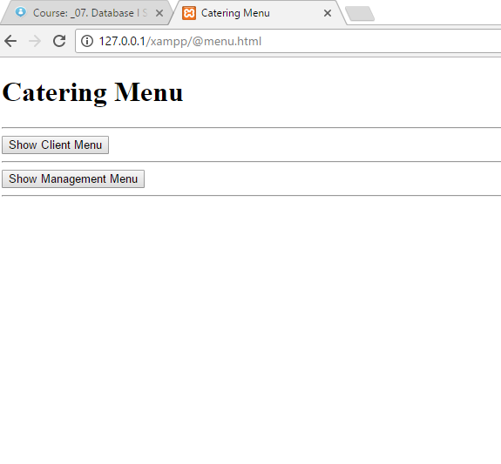

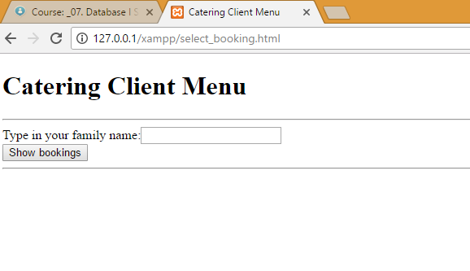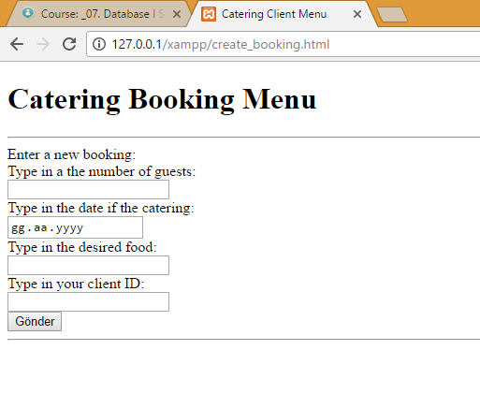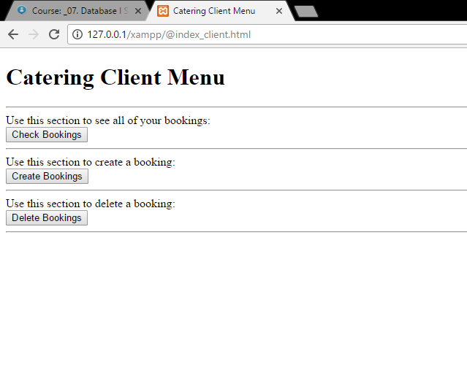

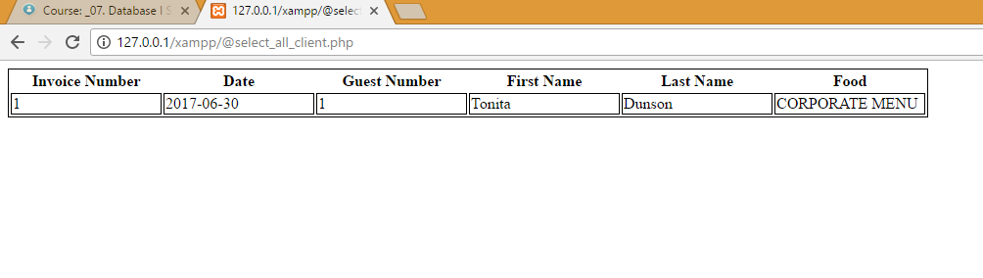

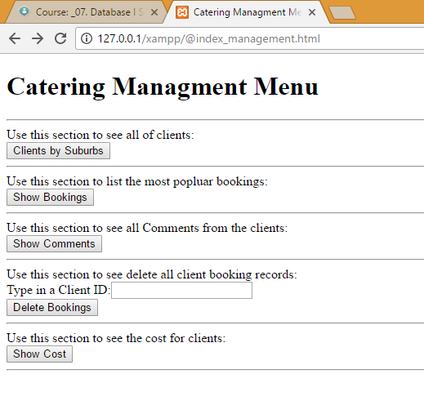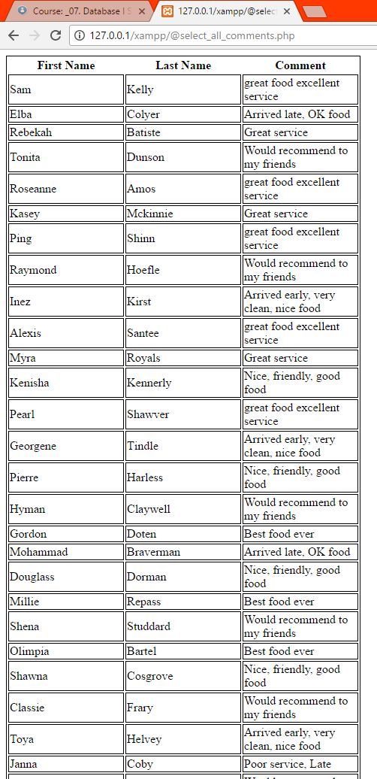

# SECURITY

1. Describe what you need to do to the PHP/Java environment to prevent error messages displaying to the public.

We can turn off error displaying by int error_reporting(int $level) command.

1. Describe changes you need to make to your PHP/Java program to minimize potential database attacks.

We can turn off error displaying to the public for minimize potential database attacks. Also, we can add a check algorithm for inputs. Inputs should not be directly affect the sql commands.

# RECOMMENDATIONS

1. All fields in your database must have appropriately-defined data types. Explain how your application handles data entry errors when one of the constraints is violated e.g. digits are entered into a first name field.

There will be no error for this situation. Because application will accept that entry as string. But, there will be no matches for that input.

1. Explain how your application behaves when it cannot connect to the database (note: your application MUST behave gracefully in such situations)

Application will show an error about connection to database

1. Provide an explanation of alternative strategies for managing disconnected data.

When database is disconnected, an error message shows up. Additionally, application can try to reconnect in every certain number of minutes automatically. Moreover, we can try to restore the data in local disk. And when connection is up , it can sync the data from there.